Q17 B

Q18

|  |  |  |  |  |
| --- | --- | --- | --- | --- |
| Length=1500 | ID=x | Fragflag=1 | Offset=0 | 1500=20+1480 |
| Length=1500 | ID=x | Fragflag=1 | Offset=1480 | 1500=20+1480 |
| Length=1040 | ID=x | Fragflag=0 | Offset=2960 | 1040=20+1020 |

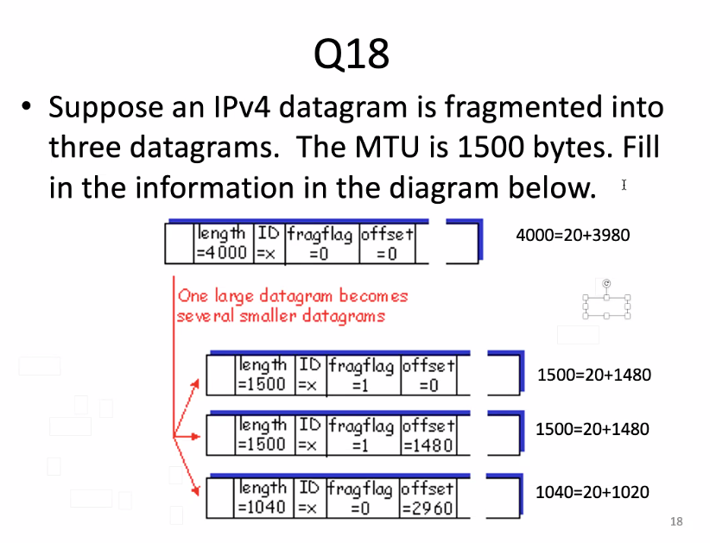

Q19 The shortest path is a-b-c-d, the cost is 6

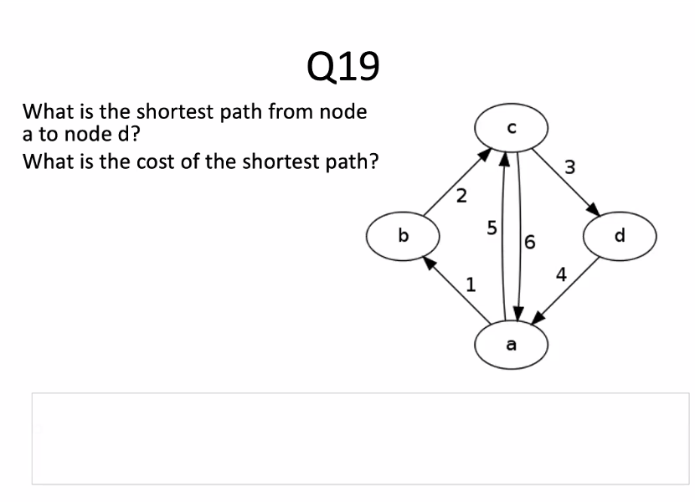

Q20 There is no such shortest path because there is a negative cycle.

